Trial Design Document
This document explains the design evaluation trials of large language models (LLMs) as well as describes the flow of data from the dataset to the result of the trial. Please note that the diagram below is annotated with numbers that correspond to the Data Flow section of the document. The named components in the diagram are described in the Trial Components section.
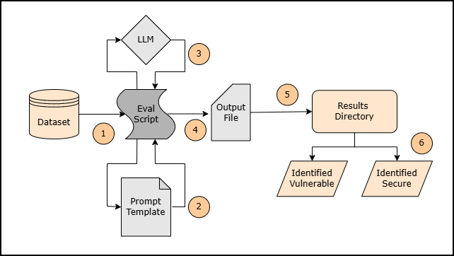
Trial Components
The LLM evaluation trials are comprised of six components. Those six components are the following: the dataset, evaluation script, prompt template, LLM, output file, and results directory.
Dataset
The dataset is the collection of source code samples for the vulnerability the LLM is being evaluated on. Every dataset will be a 50/50 mixture of vulnerable and secure code samples.

Evaluation Script
The evaluation script is the functional code that is responsible for retrieving the samples from the dataset, filling the prompt template with the source code sample, prompting the LLM, and outputting the results into the appropriate directory.
Prompt Template
The prompt template is a pre-prepared prompt that indicates to the LLM what the input format, what to do with the input, and how to respond. The prompt template will have a section for the source code sample to be inserted.
To ensure consistency among LLM evaluations of different vulnerabilities, all vulnerabilities will use the same prompt with the only differences being the vulnerability the LLM is instructed to look for and the samples inserted.
Output File
The output file is a text file that contains the LLM’s formatted response to the prompt. Each output file will be named [sampleName]_Result.txt to ensure that it is clear what source code sample the output file belongs to.
Results Directory
The results directory is a folder to store the output files from the LLM evaluation trials. Inside the results directory, there are two subfolders. The Identified Vulnerable folder is where output files for samples the LLM identified as “vulnerable” are stored. The Identified Secure folder is where output files for the samples the LLM identified as “secure” are stored.
Note: This directory separates the output files by how the LLM identified the samples. Output files are not separated by whether the samples were truly vulnerable or secure.

Data Flow
The data from each LLM evaluation trial will follow the process described below. In this case, data is used to refer to the information passed between trial components. This starts with a code sample from the dataset and ends with the LLM response in the output file.
- The evaluation script retrieves the source code sample from the dataset and reads the text content of the sample file.
- The evaluation script takes the prepared text from the sample and inserts it into the sample section of the prompt template.
- The evaluation script will feed the initial setup prompt to the LLM indicating what input to expect, what do with it, and how to respond (this is for the first sample only. All remaining samples will skip the setup prompt). The evaluation script then feeds the sample’s prompt into the LLM and retrieves the LLM’s response.
- The evaluation script will read the LLM’s identification and temporarily store it. Then write the LLM’s response to a text output file.
- The output file for the sample is then stored in the results directory.
- The subfolder the output file is stored in is determined by the LLM’s identification, which uses the temporary identification value stored by the evaluation script.

Remarks
The contents, descriptions, and the diagram in this document are subject to change prior to conclusion of open-source LLM evaluation trials, if the trial design is, in any way, altered or modified.
Following open-source LLM evaluation trials, the trial design will not be changed for commercial LLM evaluation trials and therefore this document will be final upon conclusion of that task.

